CURRICULUM OVERVIEW 2025
Year Group: 5 |  | Term: Autumn |  |  |  | Topic: Let’s Settle This! Anglo Saxons & Vikings
Trips: Tamworth Castle to explore Anglo Saxon life |  |  |  | Events: Christmas Production
Maths: |  |  |  | English:
Units:  Place value  Addition and subtraction  Statistics  Multiplication and Division  Area and perimeter | 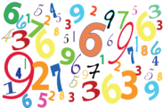  Cross-curricular opportunities:  Measure  Converting measure- maps  Statistics – presenting data |  |  | Genres:  Biography  Non-chronological report  Poetry |  |  |   Cross-curricular opportunities:  Non-chronological report/ explanations- Science  Biography/ diaries- Theme
 |  |  |  | Text: Beowulf by Michael Morpurgo and other versions.
Science:  Properties and change in materials Forces |  |  | Lead Text: |  | Art |  |  | Languages:
Knowledge/Skills: As scientists we will learn:  To know how to compare and group materials based on their properties  To understand how a material dissolves to form a solution, explaining the process of dissolving.    To know how some materials can be separated.  To understand and demonstrate how materials can be separated (e.g. through filtering, sieving and evaporating).  To understand that some changes are reversible and some are not.  To understand reversible and irreversible changes.  To understand and explain the effects o gravity.  To understand the effects of air resistance, water resistance and friction.  When working scientifically, we will: plan investigations, take measurements, record and present data, make predictions, present findings and draw conclusions. |  |  | 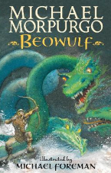 |  |   Knowledge/Skills:  As artists we will learn:  To know how effectively use a sketch book to design my ideas and to revisit and review them.  To know how to describe the different qualities involved in modelling, sculpture and construction.  To know how to plan a sculpture through drawing and other preparatory work. |  |  | 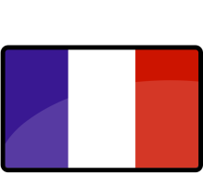  French  Pets/Home  Knowledge/Skills:  As linguists we will learn:  To listen attentively to spoken language and show understanding by joining in and responding  To explore the patterns and sounds of language through songs and rhymes and link the spelling, sound and meaning of words  To present ideas and information orally to a range of audiences  To describe people, places, things and actions orally and in writing
History: | Geography: |  |  | P.E.: |  |  |  | Design Technology:
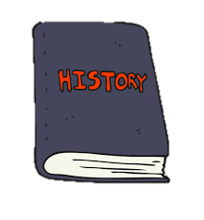  Line of enquiry:  What did the Anglo Saxons consider to be the characteristics of a good leader?  How does that compare with our perception of what a good or bad leader is?  Was Alfred the Great a ‘great’ leader? What made him ‘great’?  Does having a larger kingdom make you a better leader?  Knowledge/Skills:  As historians we will learn:  - To know and sequence key events of time studied  - To know how to use relevant terms and period labels  - To know how to make comparisons between different times in the past  - To understand how to study different aspects of different people - differences between men and women  - To understand how to examine causes and results of great events and the impact on people  - To know how to compare life in early and late 'times' studied  - To know how to compare an aspect of life with the same aspect in another period |   Locations of settlers  Migration  Origins of place names  Knowledge/Skills:  As geographers we will learn:  To know, locate and name the main counties and cities in England.  To know how to compare land use maps of UK from past with the present, focusing on land use. (History link.)  To know, describe and understand key aspects of:  Physical geography such as rivers  To know the types of settlements in Viking and Saxon Britain. (linked to History.)  To know how to use maps, atlases, globes and digital/computer mapping (Google Earth) to locate countries and describe features studied |  |  |   Dance and swimming  Knowledge/Skills:  As sports people we will learn:  Develop confidence in the water.  How to swim confidently and competently over 25m.  How to use a range of strokes effective  -how to compose street dances in creative ways  -how to combine action, balance and shapes. |  |  |  | Knowledge/Skills:  As designers we will learn:  To know how to select appropriate materials, tools and techniques  To know how to measure and mark out accurately  To know how to use skills in using different tools and equipment safely and accurately  To know how to evaluate a finished piece personally and seek evaluation from others  
Computing: | R.E.: |  |  | Music: |  |  |  | PSHE:
  Using the Internet Safely  Knowledge/Skills:  As computer users we will learn:  To know how to use technology safely, respectfully and responsibly; recognise acceptable/unacceptable behaviour; identify a range of ways to report concerns about content and contact. |   Knowledge/Skills:  When studying religion, we will learn:  To know that there are places of importance to us and some of  these are special in religious life.  To understand that Prayer is an important part of some people’s lives.  To know that different people have different scared books.  To understand questions about religious beliefs for themselves  To understand how duties and actions have consequences |  |  |   Knowledge/Skills:  As musicians we will learn:  To develop an understanding of the history of music.  How to listen with attention to detail  To describe, compare and evaluate music using musical vocabulary.  To explain why I think music is successful or unsuccessful.  To know how to breathe in the correct place when singing.  To know how to maintain my part whilst others are performing their part. |  |  |  | 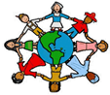  Knowledge/Skills:  As developing citizens, we will learn:  To know how to be a good friend  To know how to explain what’s on my mind.  To know how to work together.  To understand social problem solving  To know how to make things right.  To know how to be reflective

